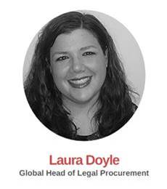

**LAURA DOYLE –** Global Head of Legal Procurement

Laura holds a Master of Letters in International Business from the University of St Andrews. Her experience in procuring legal service is wide-ranging, including conducting legal panel exercises, implementing complex eBilling and matter management systems, growing Legal Process Outsourcing capabilities within organizations, establishing performance management initiatives working with the various general counsels to conduct performance assessments. Laura also has experience in building and running successful eAuctions specifically for legal services (30+ auctions).

Laura has extensive experience in the banking industry. Laura has also worked across a number of categories of spend including HR (Employee Benefits, Pensions, Employee Assistance Programmes, Employee Health) and consultancy during her time in procurement.



**SILVER LEHNER – e**Discovery Specialist

Silvan is a CEDS-certified eDiscovery professional who has worked for a big 4 consulting firm and major pharmaceutical company. His expertise in operational efficiency informs all of his work for Yerra eDiscovery clients. He began his career with Yerra in Basel, Switzerland and proved so valuable to a major client that he was relocated to Singapore to ramp up eDiscovery operations there. Silvan holds a Business Administration degree from the University of Basel. By summer 2017, he will then be relocated to USA.